Austin Smothers

Professor Bustamante

CSC 137

July 3, 2019

Assignment 5

State Diagram:

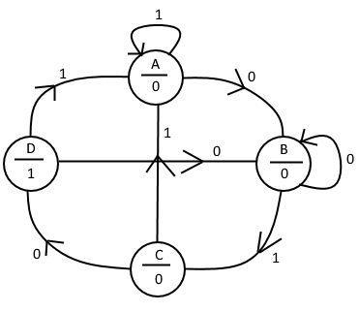

State Assignment:

{ A = 00 C = 10}

{ B = 01 D = 11}

State Table:

|  |  |  |  |  |  |
| --- | --- | --- | --- | --- | --- |
| Q1 | Q0 | X (input) | Q1+ | Q0+ | Y (output) |
| 0 | 0 | 0 | 0 | 1 | 0 |
| 0 | 0 | 1 | 0 | 0 | 0 |
| 0 | 1 | 0 | 0 | 1 | 0 |
| 0 | 1 | 1 | 1 | 0 | 0 |
| 1 | 0 | 0 | 1 | 1 | 1 |
| 1 | 0 | 1 | 0 | 0 | 0 |
| 1 | 1 | 0 | 0 | 1 | 0 |
| 1 | 1 | 1 | 0 | 0 | 0 |

K-Map Minimization:

Q1+:

|  |  |  |  |  |  |
| --- | --- | --- | --- | --- | --- |
| Q1 | Q0 X | 00 | 01 | 11 | 10 |
| 0 | | 0 | 0 | 1 | 0 |
| 1 | | 1 | 0 | 0 | 0 |

Q1+ = (Q1) + (Q0X)

Q0+:

|  |  |  |  |  |  |
| --- | --- | --- | --- | --- | --- |
| Q1 | Q0 X | 00 | 01 | 11 | 10 |
| 0 | | 1 | 0 | 0 | 1 |
| 1 | | 1 | 0 | 0 | 1 |

Q0+ =

y:

|  |  |  |  |  |  |
| --- | --- | --- | --- | --- | --- |
| Q1 | Q0 X | 00 | 01 | 11 | 10 |
| 0 | | 0 | 0 | 0 | 0 |
| 1 | | 1 | 0 | 0 | 0 |

y = Q1

Circuit Diagram:

